Electricity - 10
CLASS 10 - SCIENCE

 | Section A
1 | Assertion (A): When the length of a wire is doubled, thenits resistance also gets doubled. Reason(R): The resistance of a wire is directly proportional to its length.  a) Both A and R are true and R is the correct explanation of A.  b) Both A and R are true but R is not the correct explanation of A.  c) A is true but R is false.  d) A is false but R is true. | [1]
2 | Assertion (A): The coil of a heater is cut into two equal halves and only one of them is used into heater. The heater will now require half the time to produce the same amount of heat. Reason (R): The heat produced is directly proportional to square of current.  a) Both A and R are true and R is the correct explanation of A.  b) Both A and R are true but R is not the correct explanation of A.  c) A is true but R is false.  d) A is false but R is true. | [1]
3 | Assertion (A): Resistance of 50 W bulb is greater thanthat of 100 W. Reason (R): Resistance of bulb is inversely proportional to rated power.  a) Both A and R are true and R is the correct explanation of A.  b) Both A and R are true but R is not the correct explanation of A.  c) A is true but R is false.  d) A is false but R is true. | [1]
4 | Assertion (A): Silver is not used to make electric wires. Reason (R): Silver is a bad conductor.  a) Both A and R are true and R is the correct explanation of A.  b) Both A and R are true but R is not the correct explanation of A.  c) A is true but R is false.  d) A is false but R is true. | [1]
5 | Assertion (A): In a circuit which is having 3 series resistors of R ohm each, the total resistance of the circuit will be 3R. Reason (R): As in parallel circuit the resultant resistance will be $\frac{1}{R}=\frac{1}{R_{1}}+\frac{1}{R_{2}}+\frac{1}{R_{3}}$ .  a) Both A and R are true and R is the correct explanation of A.  b) Both A and R are true but R is not the correct explanation of A.  c) A is true but R is false.  d) A is false but R is true. | [1]
6 | Assertion (A): A bird perches on a high power line and nothing happens to the bird. Reason (R): The circuit is incomplete for the bird sitting on high power line.  a) Both A and R are true and R is the correct explanation of A.  b) Both A and R are true but R is not the correct explanation of A.  c) A is true but R is false.  d) A is false but R is true. | [1]
7 | Assertion (A): Wire A is thin in comparison to wire B of same material same length then resistance of wire A is greater than resistance of wire B. Reason (R): Resistivity of wire A is greater than resistance of wire B.  a) Both A and R are true and R is the correct explanation of A.  b) Both A and R are true but R is not the correct explanation of A.  c) A is true but R is false.  d) A is false but R is true. | [1]
8 | Assertion (A): In a chain of bulbs, 50 bulbs are joined in series. One bulb is removed now and circuit is completed again. If the remaining 49 bulbs are again connected in series across the same supply, then light gets decreased in the room. Reason (R): Net resistance of 49 bulbs will be less than 50 bulbs.  a) Both A and R are true and R is the correct explanation of A.  b) Both A and R are true but R is not the correct explanation of A.  c) A is true but R is false.  d) A is false but R is true. | [1]
9 | Assertion (A): If 10 bulbs are connected in series and one bulb fused, then the remaining 9 bulbs will not work. Reason (R): Bulb of higher wattage will give less bright light.  a) Both A and R are true and R is the correct explanation of A.  b) Both A and R are true but R is not the correct explanation of A.  c) A is true but R is false.  d) A is false but R is true. | [1]
10 | Assertion (A): Tungsten metal is used for making filaments of incandescent lamps. Reason (R): The melting point of tungsten is very low.  a) Both A and R are true and R is the correct explanation of A.  b) Both A and R are true but R is not the correct explanation of A.  c) A is true but R is false.  d) A is false but R is true. | [1]
11 | Assertion (A): Two resistance having value Reach. Their equivalent resistance is $\frac{R}{2}$ . Reason (R): Given Resistance is connected in parallel.  a) Both A and R are true and R is the correct explanation of A.  b) Both A and R are true but R is not the correct explanation of A.  c) A is true but R is false.  d) A is false but R is true. | [1]
12 | Assertion (A): The value of the current in the ammeter is the same, independent of its position in the electric circuit. Reason (R): In a series combination of resistors the current is the same in every part of the circuit or the same current through each resistor.  a) Both A and R are true and R is the correct explanation of A.  b) Both A and R are true but R is not the correct explanation of A.  c) A is true but R is false.  d) A is false but R is true. | [1]
13 | Assertion (A): Alloys are commonly used in electrical heating devices, like electrical iron, toasters etc. Reason (R): Alloys do not oxidize (burn) readily at high temperatures.  a) Both A and R are true and R is the correct explanation of A.  b) Both A and R are true but R is not the correct explanation of A  c) A is true but R is false.  d) A is false but R is true. | [1]
14 | Assertion (A): A torch bulb gives light if operated on AC of the same voltage and current as DC. Reason (R): The heating effect is common to both AC and DC.  a) Both A and R are true and R is the correct explanation of A.  b) Both A and R are true but R is not the correct explanation of A.  c) A is true but R is false.  d) A is false but R is true. | [1]
15 | Assertion (A): Bulbs are filled with inactive nitrogen and argon gases. Reason (R): As there is a requirement of thermal isolation of the filament.  a) Both A and R are true and R is the correct explanation of A.  b) Both A and R are true but R is not the correct explanation of A.  c) A is true but R is false.  d) A is false but R is true. | [1]
16 | Assertion (A): If a graph is plotted between the potential difference and the current flowing, the graph is a straight line passing through the origin. Reason (R): The current is directly proportional to the potential difference.  a) Both A and R are true and R is the correct explanation of A.  b) Both A and R are true but R is not the correct explanation of A.  c) A is true but R is false.  d) A is false but R is true. | [1]
17 | Assertion (A): A conductor has +3.2 $×$ 10 $​^{−19}$ C charge. Reason (R): Conductor has gained 2 electrons.  a) Both A and R are true and R is the correct explanation of A.  b) Both A and R are true but R is not the correct explanation of A.  c) A is true but R is false.  d) A is false but R is true. | [1]
18 | Assertion (A): When the resistances are connected end - to - end consecutively, they are said to be in series. Reason (R): In case the total resistance is to be increased, then the individual resistances are connected in series.  a) Both A and R are true and R is the correct explanation of A.  b) Both A and R are true but R is not the correct explanation of A.  c) A is true but R is false.  d) A is false but R is true. | [1]
19 | Assertion (A): Good conductors of heat are also good conductors of electricity and vice versa. Reason (R): Mainly electrons are responsible for conduction.  a) Both A and R are true and R is the correct explanation of A.  b) Both A and R are true but R is not the correct explanation of A.  c) A is true but R is false.  d) A is false but R is true. | [1]
20 | Assertion (A): Copper is used to make electric wires. Reason (R): Copper has very low electrical resistance.  a) Both A and R are true and R is the correct explanation of A.  b) Both A and R are true but R is not the correct explanation of A.  c) A is true but R is false.  d) A is false but R is true. | [1]
21 | Assertion (A): The connecting wires are made of copper. Reason (R): The electrical conductivity of copper is high.  a) Both A and R are true and R is the correct explanation of A.  b) Both A and R are true but R is not the correct explanation of A.  c) A is true but R is false.  d) A is false but R is true. | [1]
22 | Assertion (A): When the current through a bulb decreases by 0.5% the glow of the bulb decreases by 1%. Reason (R): Glow (Power) is directly proportional to the square of the current.  a) Both A and R are true and R is the correct explanation of A.  b) Both A and R are true but R is not the correct explanation of A.  c) A is true but R is false.  d) A is false but R is true. | [1]
23 | Assertion (A): Electric current flowing through a metallic wire is directly proportional to the potential difference across its ends. Reason (R): Ohms law expression V = IR, where R (resistance) of the wire is always varying.  a) Both A and R are true and R is the correct explanation of A.  b) Both A and R are true but R is not the correct explanation of A.  c) A is true but R is false.  d) A is false but R is true. | [1]
24 | Assertion (A): The product of resistivity and conductivity of a conductor depends on the material of the conductor. Reason (R): Because each resistivity and conductivity depends on the material of the conductor.  a) Both A and R are true and R is the correct explanation of A.  b) Both A and R are true but R is not the correct explanation of A.  c) A is true but R is false.  d) A is false but R is true. | [1]
25 | Assertion (A): Fuse wire must have high resistance and low melting point. Reason (R): Fuse is used for small current flow only.  a) Both A and R are true and R is the correct explanation of A.  b) Both A and R are true but R is not the correct explanation of A.  c) A is true but R is false.  d) A is false but R is true. | [1]
26 | Assertion (A): When a wire is stretched to three times of its length, its resistance becomes 9 times. Reason (R): Resistance is directly proportional to length of wire.  a) Both A and R are true and R is the correct explanation of A.  b) Both A and R are true but R is not the correct explanation of A.  c) A is true but R is false.  d) A is false but R is true. | [1]
27 | Assertion (A): When area of the conductor is halved then the resistance of the material gets doubled when length is kept constant. Reason (R): Because resistance is inversely proportional to the area of a cross - section of the material.  a) Both A and R are true and R is the correct explanation of A.  b) Both A and R are true but R is not the correct explanation of A.  c) A is true but R is false.  d) A is false but R is true. | [1]
28 | Assertion (A): The wires supplying current to an electric heater are not heated appreciably. Reason (R): Resistance of connecting wires is very small and H $∝$ R.  a) Both A and R are true and R is the correct explanation of A.  b) Both A and R are true but R is not the correct explanation of A.  c) A is true but R is false.  d) A is false but R is true. | [1]
29 | Assertion (A): 40 W tube light gives more light in comparison to 40 W bulb. Reason (R): Light produced is same from same power.  a) Both A and R are true and R is the correct explanation of A.  b) Both A and R are true but R is not the correct explanation of A.  c) A is true but R is false.  d) A is false but R is true. | [1]
30 | Assertion (A): Long - distance power transmission is doneat high voltage. Reason (R): At high voltage supply power losses are less.  a) Both A and R are true and R is the correct explanation of A.  b) Both A and R are true but R is not the correct explanation of A.  c) A is true but R is false.  d) A is false but R is true. | [1]
31 | Assertion (A): If $ρ_{1}$ and $ρ_{2}$ be the resistivity of the materials of two resistors of resistances R $​_{1}$ and R $​_{2}$ respectively and R $​_{1}$ > R $​_{2}$ . Reason (R): The resistance R = $\begin{matrix}ρ\frac{l}{A}⇒ρ_{1} >ρ_{2}\end{matrix}$ if R $​_{1}$ > R $​_{2}$  a) Both A and R are true and R is the correct explanation of A.  b) Both A and R are true but R is not the correct explanation of A.  c) A is true but R is false.  d) A is false but R is true. | [1]
32 | Assertion (A): A tube light emits white light. Reason (R): Emission of light in a tube takes place at a very high temperature.  a) Both A and R are true and R is the correct explanation of A.  b) Both A and R are true but R is not the correct explanation of A.  c) A is true but R is false.  d) A is false but R is true. | [1]
33 | Assertion (A): A resistor of resistance R is connected to an ideal battery. If the value of R is decreased, the power dissipated in the circuit will increase. Reason (R): The power dissipated in the circuit will increase.  a) Both A and R are true and R is the correct explanation of A.  b) Both A and R are true but R is not the correct explanation of A.  c) A is true but R is false.  d) A is false but R is true. | [1]
34 | Assertion (A): The resistivity of the conductor increases withthe increase of temperature. Reason (R): The resistivity is the reciprocal of the conductivity.  a) Both A and R are true and R is the correct explanation of A.  b) Both A and R are true but R is not the correct explanation of A.  c) A is true but R is false.  d) A is false but R is true. | [1]
35 | Assertion (A): Alloys are used in making electric irons, toasters etc. Reason (R): Because the resistivity of alloys is lower than its constituent metals.  a) Both A and R are true and R is the correct explanation of A.  b) Both A and R are true but R is not the correct explanation of A.  c) A is true but R is false.  d) A is false but R is true. | [1]
36 | Assertion (A): It is advantageous to transmit electric power at high voltage. Reason (R): High voltage implies high current.  a) Both A and R are true and R is the correct explanation of A.  b) Both A and R are true but R is not the correct explanation of A.  c) A is true but R is false.  d) A is false but R is true. | [1]
37 | Assertion (A): When a battery is short - circuited, the terminal voltage is zero. Reason (R): In the situation of a short - circuit, the current is zero.  a) Both A and R are true and R is the correct explanation of A.  b) Both A and R are true but R is not the correct explanation of A.  c) A is true but R is false.  d) A is false but R is true. | [1]
38 | Assertion (A): Electric appliances with metallic body have three connections, whereas an electric bulb has a two - pin connection. Reason (R): Three - pin connections reduce the heating of connecting wires.  a) Both A and R are true and R is the correct explanation of A.  b) Both A and R are true but R is not the correct explanation of A.  c) A is true but R is false.  d) A is false but R is true. | [1]
39 | Assertion (A): Resistivity of the material may change with temperature. Reason (R): Resistivity is a material property & independent of temperature.  a) Both A and R are true and R is the correct explanation of A.  b) Both A and R are true but R is not the correct explanation of A.  c) A is true but R is false.  d) A is false but R is true. | [1]
40 | Assertion (A): The 200 W bulbs glow with more brightnessthan 100 W bulbs. Reason (R): A 100 W bulb has more resistance than 200 W bulb.  a) Both A and R are true and R is the correct explanation of A.  b) Both A and R are true but R is not the correct explanation of A.  c) A is true but R is false.  d) A is false but R is true. | [1]
41 | Assertion (A): Longer wires have greater resistance and the smaller wires have lesser resistance. Reason (R): Resistance is inversely proportional to the length of the wire.  a) Both A and R are true and R is the correct explanation of A.  b) Both A and R are true but R is not the correct explanation of A.  c) A is true but R is false.  d) A is false but R is true. | [1]
42 | Assertion (A): The electric bulbs glow immediately when the switch is on. Reason (R): The drift velocity of electrons in a metallic wire is very high.  a) Both A and R are true and R is the correct explanation of A.  b) Both A and R are true but R is not the correct explanation of A.  c) A is true but R is false.  d) A is false but R is true. | [1]
43 | Assertion (A): At high temperatures, metal wires have a greater chance of short - circuiting. Reason (R): Both resistance and resistivity of a material vary with temperature.  a) Both A and R are true and R is the correct explanation of A.  b) Both A and R are true but R is not the correct explanation of A.  c) Ais true but Ris false.  d) A is false but R is true. | [1]
44 | Assertion (A): Voltmeter is always connected in parallel across the circuit while measuring the potential difference. Reason (R): As the voltage in parallel circuits are measured to be the same.  a) Both A and R are true and R is the correct explanation of A.  b) Both A and R are true but R is not the correct explanation of A.  c) A is true but R is false.  d) A is false but R is true. | [1]
45 | Assertion (A): Electron has a negative charge. Reason (R): Electrons move always from a region of higher potential to a region of lower potential.  a) Both A and R are true and R is the correct explanation of A.  b) Both A and R are true but R is not the correct explanation of A.  c) A is true but R is false.  d) A is false but R is true. | [1]
46 | Assertion (A): A voltmeter and ammeter can be usedtogether to measure resistance but not power. Reason (R): Power is proportional to voltage and current.  a) Both A and R are true and R is the correct explanation of A.  b) Both A and R are true but R is not the correct explanation of A.  c) A is true but R is false.  d) A is false but R is true. | [1]
47 | Assertion (A): When the resistances are connected between the same two points, they are said to be connected in parallel. Reason (R): In case the resistance is to be decreased, then the individual resistances are connected in parallel.  a) Both A and R are true and R is the correct explanation of A.  b) Both A and R are true but R is not the correct explanation of A.  c) A is true but R is false.  d) A is false but R is true. | [1]
48 | Assertion (A): Heater wire must have high resistance willbe the melting point. Reason (R): If resistance is high, the electric conductivity will be less.  a) Both A and R are true and R is the correct explanation of A.  b) Both A and R are true but R is not the correct explanation of A.  c) A is true but R is false.  d) A is false but R is true. | [1]
49 | Assertion (A): Insulators do not allow the flow of current through themselves. Reason (R): They have no free - charge carriers.  a) Both A and R are true and R is the correct explanation of A.  b) Both A and R are true but R is not the correct explanation of A.  c) A is true but R is false.  d) A is false but R is true. | [1]
50 | Assertion (A): Current is the rate of flow of charge. Reason (R): Electric current will not flow between two charged bodies when connected, if they are at same potential.  a) Both A and R are true and R is the correct explanation of A.  b) Both A and R are true but R is not the correct explanation of A.  c) A is true but R is false.  d) A is false but R is true. | [1]
51 | Assertion (A): Positive charge inside the cell always goesfrom positive terminal to the negative terminal. Reason(R): Positive charge inside the cell may go from negative terminal to the positive terminal.  a) Both A and R are true and R is the correct explanation of A.  b) Both A and R are true but R is not the correct explanation of A.  c) A is true but R is false.  d) A is false but R is true. | [1]
52 | Assertion (A): Electric current starts flowing through a conductor. Reason (R): Due to the flow of electric charges in the conductor.  a) Both A and R are true and R is the correct explanation of A.  b) Both A and R are true but R is not the correct explanation of A.  c) A is true but R is false.  d) A is false but R is true. | [1]
53 | Assertion (A): When more current flows to an electrical equipment it shows more heating of the same. Reason (R): Heat flow is directly proportional to the square of current only.  a) Both A and R are true and R is the correct explanation of A.  b) Both A and R are true but R is not the correct explanation of A.  c) A is true but R is false.  d) A is false but R is true. | [1]
54 | Assertion (A): In a simple battery circuit the point of lowest potential is the negativeterminal of the battery. Reason (R): The current flows towards the point of the lower potential as it flows in such a circuit from the negative to the positive terminal.  a) Both A and R are true and R is the correct explanation of A.  b) Both A and R are true but R is not the correct explanation of A.  c) A is true but R is false.  d) A is false but R is true. | [1]
55 | Assertion (A): The equation V = Ri does not apply to those conducting. devices that do not obey Ohm’s law. Reason (R): V = RI is a statement of Ohm’s law.  a) Both A and R are true and R is the correct explanation of A.  b) Both A and R are true but R is not the correct explanation of A.  c) A is true but R is false.  d) A is false but R is true. | [1]
56 | Assertion (A): A current carrying wire should be charged. Reason (R): The current in a wire is due to flow of free electrons in a definite direction.  a) Both A and R are true and R is the correct explanation of A.  b) Both A and R are true but R is not the correct explanation of A.  c) A is true but R is false.  d) A is false but R is true. | [1]
57 | Assertion (A): Bending a wire does not affect electrical resistance. Reason (R): Resistance of wire is proportional to the resistivity of the material.  a) Both A and R are true and R is the correct explanation of A.  b) Both A and R are true but R is not the correct explanation of A.  c) A is true but R is false.  d) A is false but R is true. | [1]
58 | Assertion (A): All electric devices shown in the circuit are ideal. The reading of each ammeter (a) and voltmeter (V) is zero. 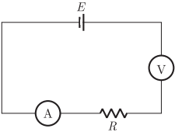  Reason (R): An ideal voltmeter draws almost no current due to very large resistance, and hence (V) and (a) will read zero.  a) Both A and R are true and R is the correct explanation of A.  b) Both A and R are true but R is not the correct explanation of A.  c) A is true but R is false.  d) A is false but R is true. | [1]
 | Section B
59 | Match the following with correct response: 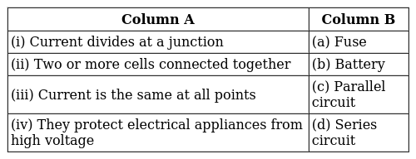  a) (i) - (c), (ii) - (b), (iii) - (d), (iv) - (a)  b) (i) - (d), (ii) - (a), (iii) - (c), (iv) - (b)  c) (i) - (b), (ii) - (d), (iii) - (a), (iv) - (c)  d) (i) - (a), (ii) - (c), (iii) - (b), (iv) - (d) | [1]
60 | Match the following with the correct response: 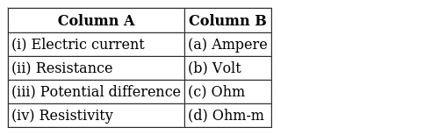  a) (i) - (a), (ii) - (c), (iii) - (b), (iv) - (d)  b) (i) - (d), (ii) - (a), (iii) - (c), (iv) - (b)  c) (i) - (b), (ii) - (d), (iii) - (a), (iv) - (c)  d) (i) - (c), (ii) - (b), (iii) - (d), (iv) - (a) | [1]
61 | Match the following with the correct response: 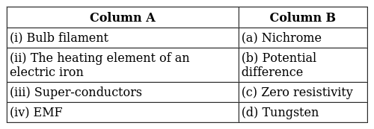  a) (i) - (b), (ii) - (d), (iii) - (a), (iv) - (c)  b) (i) - (c), (ii) - (b), (iii) - (d), (iv) - (a)  c) (i) - (a), (ii) - (c), (iii) - (b), (iv) - (d)  d) (i) - (d), (ii) - (a), (iii) - (c), (iv) - (b) | [1]
62 | Match the following with the correct response: 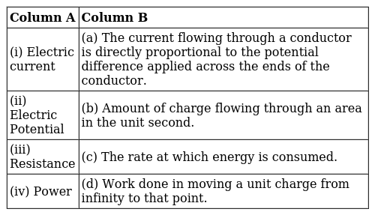  a) (i) - (b), (ii) - (d), (iii) - (a), (iv) - (c)  b) (i) - (a), (ii) - (c), (iii) - (b), (iv) - (d)  c) (i) - (c), (ii) - (b), (iii) - (d), (iv) - (a)  d) (i) - (d), (ii) - (a), (iii) - (c), (iv) - (b) | [1]
63 | Match the following with the correct response: 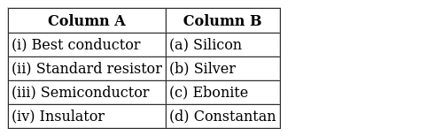  a) (i) - (d), (ii) - (a), (iii) - (c), (iv) - (b)  b) (i) - (a), (ii) - (c), (iii) - (b), (iv) - (d)  c) (i) - (b), (ii) - (d), (iii) - (a), (iv) - (c)  d) (i) - (c), (ii) - (b), (iii) - (d), (iv) - (a) | [1]
64 | Match the following with the correct response: 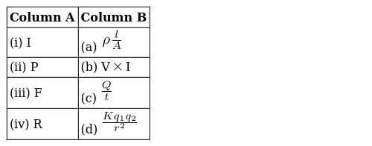  a) (i) - (a), (ii) - (c), (iii) - (b), (iv) - (d)  b) (i) - (d), (ii) - (a), (iii) - (c), (iv) - (b)  c) (i) - (c), (ii) - (b), (iii) - (d), (iv) - (a)  d) (i) - (b), (ii) - (d), (iii) - (a), (iv) - (c) | [1]
65 | Match the following with the correct response: 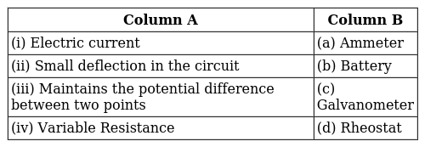  a) (i) - (b), (ii) - (d), (iii) - (a), (iv) - (c)  b) (i) - (c), (ii) - (b), (iii) - (d), (iv) - (a)  c) (i) - (a), (ii) - (c), (iii) - (b), (iv) - (d)  d) (i) - (d), (ii) - (a), (iii) - (c), (iv) - (b) | [1]
66 | Match the components in column A with the symbols in column B. 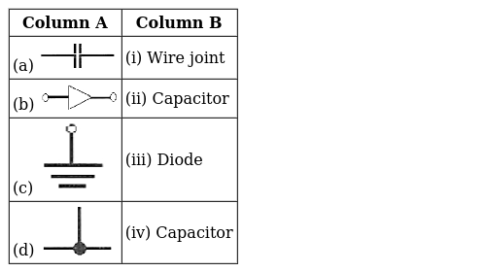  a) (a) - (iv), (b) - (i), (c) - (ii), (d) - (iii)  b) (a) - (i), (b) - (ii), (c) - (i), (d) - (iv)  c) (a) - (iii), (b) - (iv), (c) - (iii), (d) - (ii)  d) (a) - (ii), (b) - (iii), (c) - (iv), (d) - (i) | [1]
67 | Match the following with the correct response: 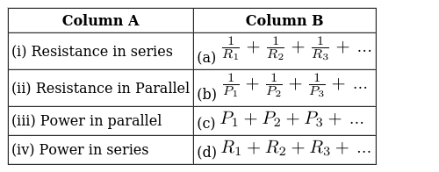  a) (i) - (d), (ii) - (a), (iii) - (c), (iv) - (b)  b) (i) - (b), (ii) - (d), (iii) - (a), (iv) - (c)  c) (i) - (a), (ii) - (c), (iii) - (b), (iv) - (d)  d) (i) - (c), (ii) - (b), (iii) - (d), (iv) - (a) | [1]
68 | Match the following with the correct response: 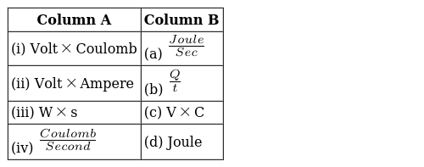  a) (i) - (b), (ii) - (d), (iii) - (a), (iv) - (c)  b) (i) - (c), (ii) - (b), (iii) - (d), (iv) - (a)  c) (i) - (d), (ii) - (a), (iii) - (c), (iv) - (b)  d) (i) - (a), (ii) - (c), (iii) - (b), (iv) - (d) | [1]
 | Section C
69 | Power is directly and inversely proportional to the________.  a) Current  b) Charge  c) Voltage  d) Resistance | [1]
70 | Current flows through a wire only when there is ________ between the ends of the wire.  a) Potential difference  b) All of these  c) Work is done in moving a charge  d) Potential difference at one end is more than at the other end | [1]
71 | Electrical resistivity of an alloy of copper and nickel is ________ when compared with the electrical resistivity of an alloy of copper, manganese and nickel.  a) Double  b) Same  c) Less  d) More | [1]
72 | If a battery provides a high voltage, it can ____  a) Do a lot of work on each charge it encounters.  b) Do a lot of work over the course of its lifetime.  c) Push a lot of charge through a circuit  d) Last a long time | [1]
 | Section D
73 | 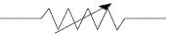  The above mentioned symbol is:  a) Variable resistance or rheostat  b) Rheostat  c) Resistance  d) Variable resistance | [1]
74 | Identify the circuit (Figure) in which the electrical components have been properly connected. 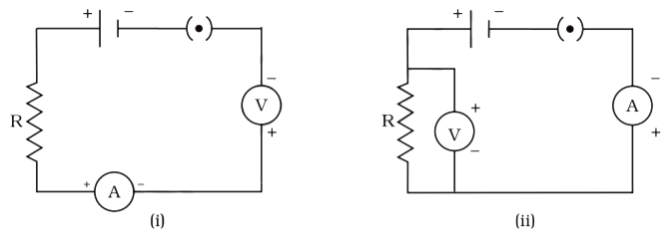  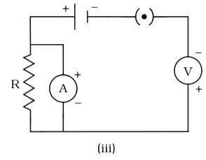  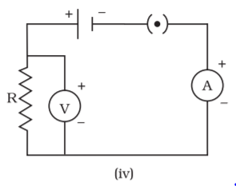  a) (iv)  b) (iii)  c) (i)  d) (ii) | [1]

